Q5. Five different degraded images are provided in the Module Section.Use suitable gray-level transformation techniques to enhance each image.After processing, describe your observations in detail for every enhancement step, explaining how the chosen operations improved the visual quality.Finally, write a clear conclusion summarizing the effectiveness and limitations of the applied gray-level techniques. CO3, CO4
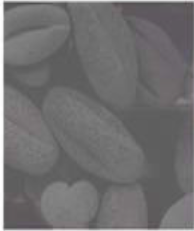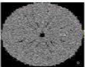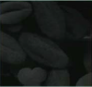
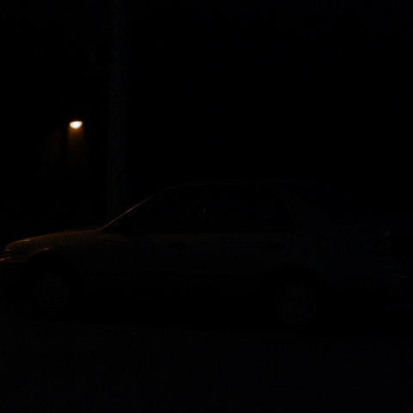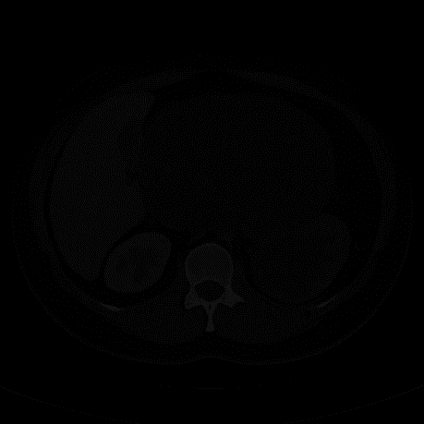
Code:

!pip install -q opencv-python matplotlib numpy

import cv2
import numpy as np
import matplotlib.pyplot as plt

def show(title, img):
plt.figure(figsize=(5,5))
plt.imshow(img, cmap='gray')
plt.title(title)
plt.axis("off")
plt.show()

# 1. Negative Transform
def negative(img):
return 255 - img

# 2. Log Transform
def log_transform(img):
img = img.astype(np.float32)
c = 255 / np.log(1 + np.max(img))
return np.uint8(c * np.log(1 + img))

# 3. Gamma Correction
def gamma_correction(img, gamma):
img_norm = img / 255.0
corrected = np.power(img_norm, gamma)
return np.uint8(corrected * 255)

# 4. Contrast Stretching
def contrast_stretch(img):
min_val = np.min(img)
max_val = np.max(img)
stretched = (img - min_val) * (255 / (max_val - min_val + 1e-10))
return stretched.astype(np.uint8)

# 5. Histogram Equalization
def hist_equalize(img):
return cv2.equalizeHist(img)

image_paths = [
"/content/Picture1.png",
"/content/Picture2.png",
"/content/Picture3.png",
"/content/Picture4.png",
"/content/Picture5.png"
]

print("Enhancing all 5 images...\n")

for path in image_paths:
print("Processing:", path)

img = cv2.imread(path, 0)
if img is None:
print("ERROR: File not found —", path)
continue

show("Original Image", img)

show("Negative Transform", negative(img))
show("Log Transform", log_transform(img))
show("Gamma Correction (γ=0.5) BRIGHT", gamma_correction(img, 0.5))
show("Gamma Correction (γ=2.0) DARK", gamma_correction(img, 2.0))
show("Contrast Stretching", contrast_stretch(img))
show("Histogram Equalization", hist_equalize(img))

print("\nDone for:", path, "\n\n")

OUTPUT:

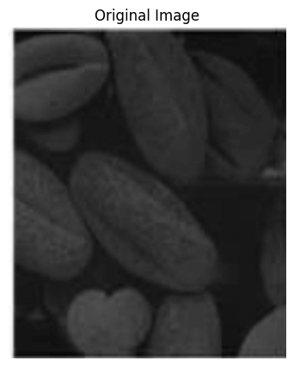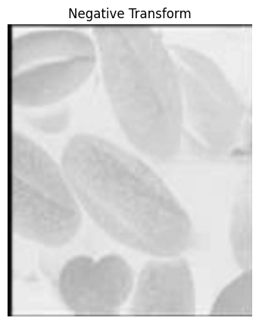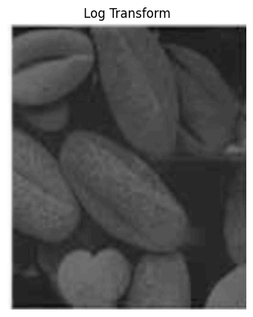
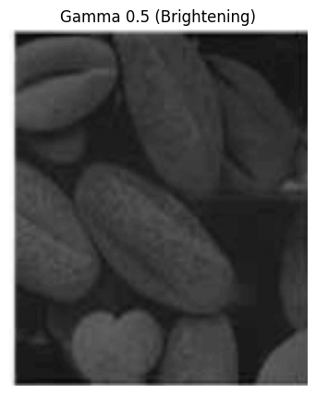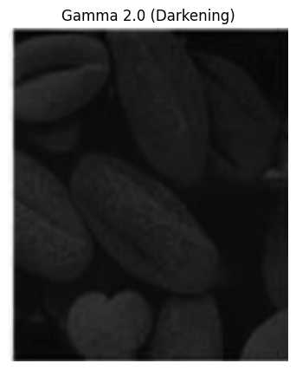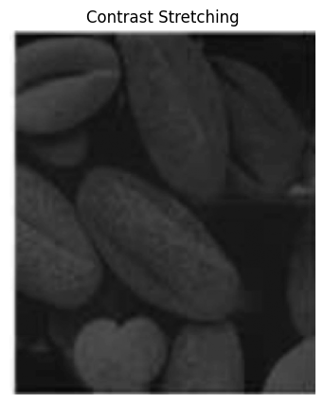

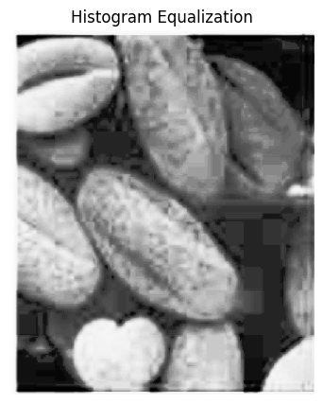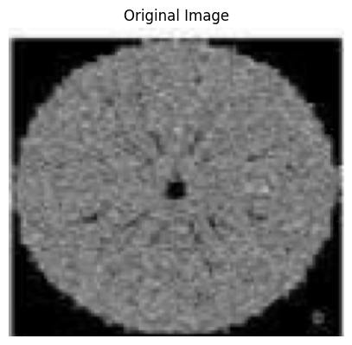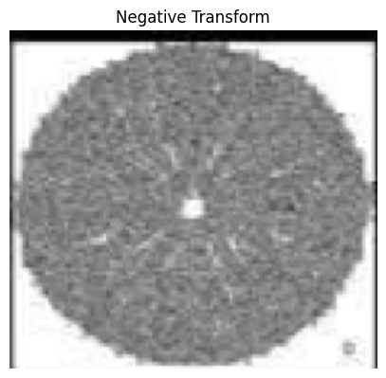

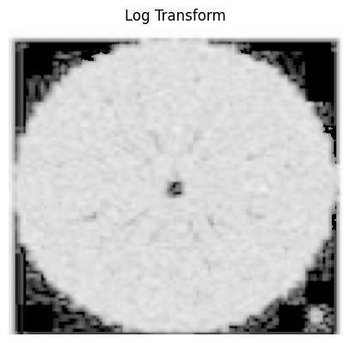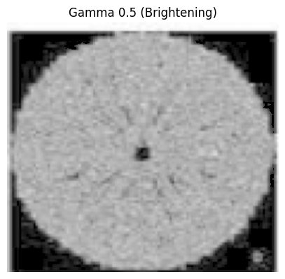

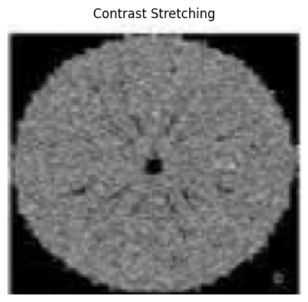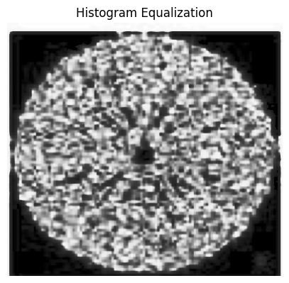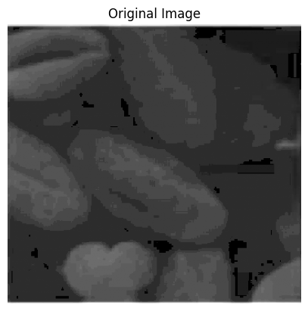

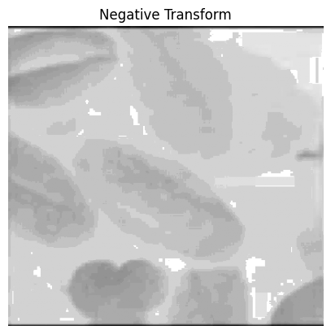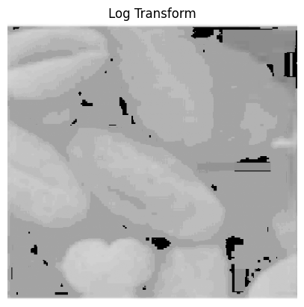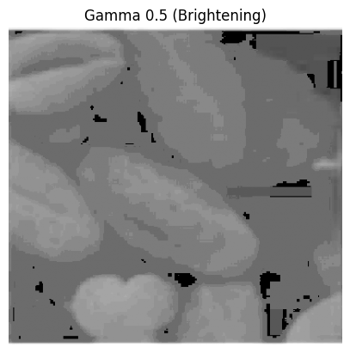

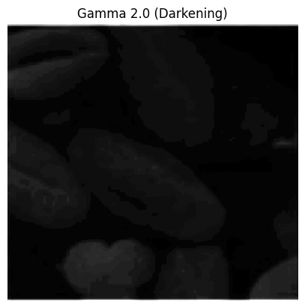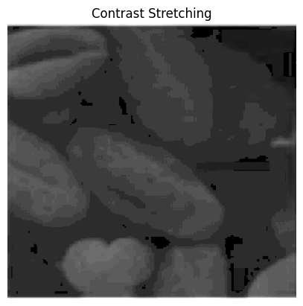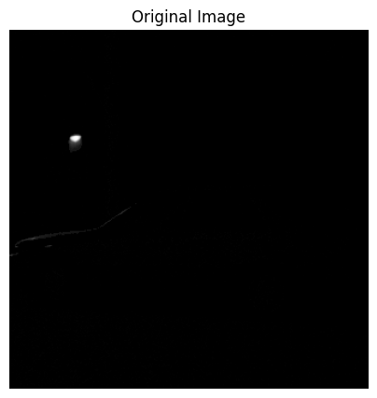

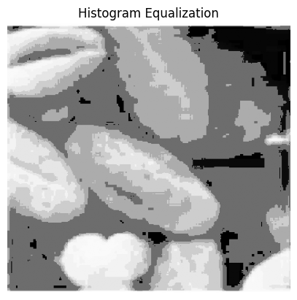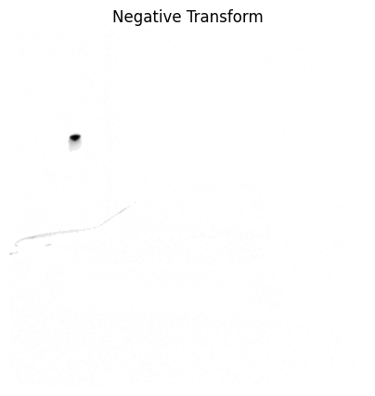

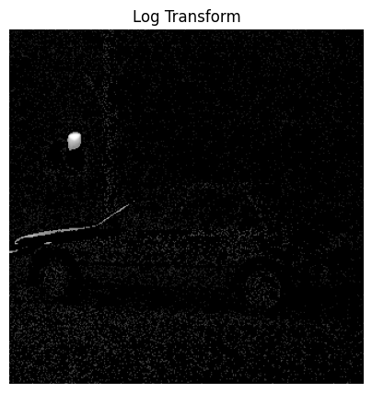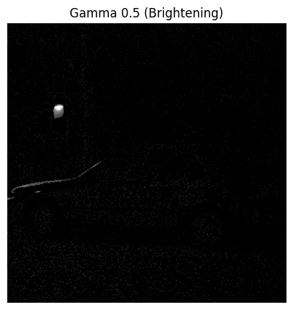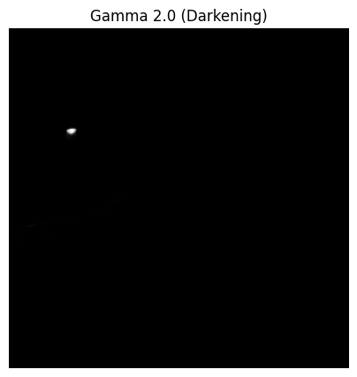

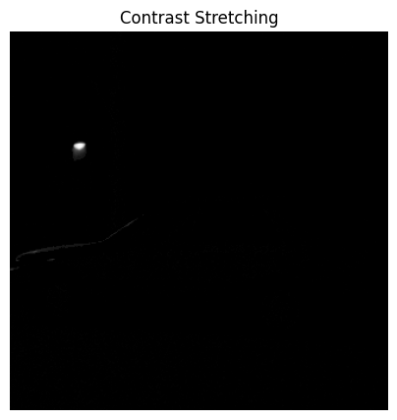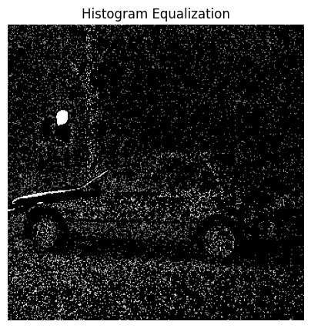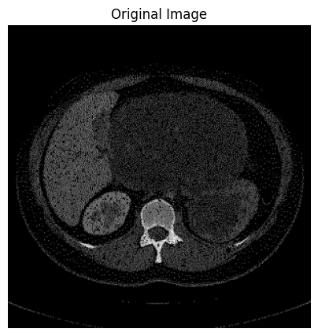

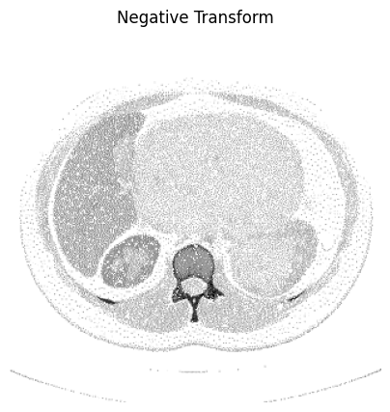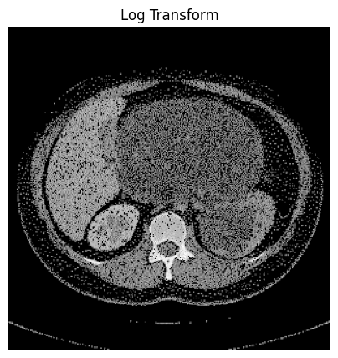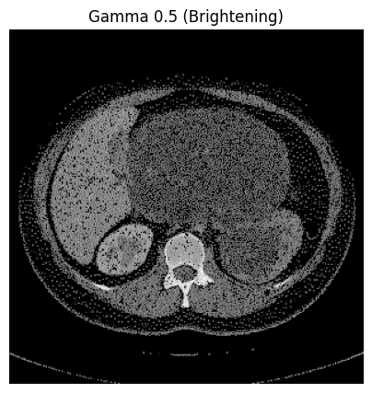

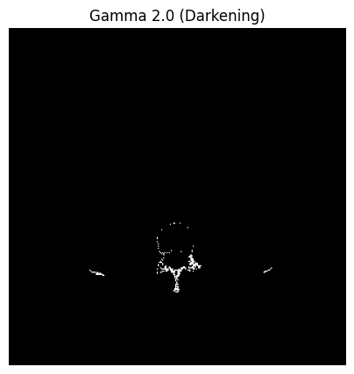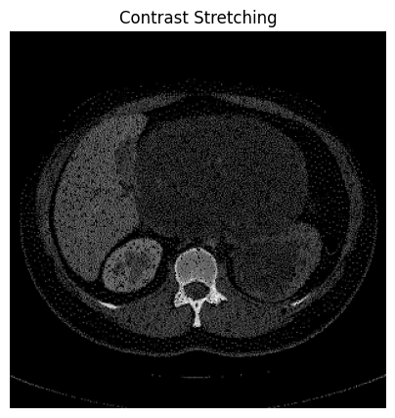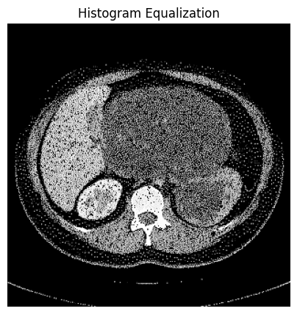

Obsevation:

1. Negative Transformation
- The negative transform inverted the brightness levels, making dark regions bright and bright regions dark.
- It enhanced details in images where important information was hidden in darker regions.
- However, for images already bright or with low contrast, the negative did not significantly improve visual clarity and sometimes made the image harder to interpret.

2. Log Transformation
- Log transform improved visibility in very dark areas by expanding low-intensity gray levels.
- It compressed the high-intensity regions, reducing over-brightness and enhancing shadow details.
- This was especially useful for images with poor lighting or extremely low contrast.
- However, images that were already well-lit showed minimal benefit.

3. Gamma Correction

γ = 0.5 (Brightening)
- Mid-tones and shadows became brighter, improving visibility in dark regions.
- Useful for images with underexposure or shadow dominance.
- In some pictures, over-brightening caused loss of detail in already bright areas.

γ = 2.0 (Darkening)
- Reduced excessive brightness and improved detail retention in highlighted areas.
- Helped control glare and highlight overexposure in light-dominated images.
- In very dark images, it made visibility worse.

4. Contrast Stretching
- Produced one of the most visually effective enhancements across all images.
- Increased separation between dark and bright pixels by stretching pixel values across the full intensity range [0–255].
- Significantly improved details in low-contrast images.
- Works best when the image histogram is narrow (poor contrast).
- In noisy images, it sometimes amplified noise along with useful details.

5. Histogram Equalization
- Provided strong global contrast enhancement and improved fine details that were previously hidden.
- Worked especially well in images with uneven or faded lighting.
- Improved clarity of textures and edges.
- However, for images with already good contrast, it introduced artifacts or unnatural brightness jumps due to over-equalization.
- In some smooth regions, noise became more visible.
Conclusion:
we observe that gray-level transformation techniques significantly improve degraded images, but their effectiveness varies depending on the type of degradation. Log and gamma corrections help enhance dark or overly bright regions by redistributing pixel intensity values. Contrast stretching and histogram equalization provide strong overall contrast enhancement, revealing hidden details and improving visual clarity. However, these techniques also have limitations—over-enhancement can introduce artifacts, amplify noise, or distort natural brightness levels. Overall, gray-level transformations are powerful tools for basic image enhancement, but selecting the appropriate method depends on the specific characteristics of each degraded image.

